**Instructions to install and use Gametes Simulator Software**

Gametes simulator software needs to have installed previously the last version of JRE Java in the operative system of your computer.

To install the last version of JRE Java: <https://www.oracle.com/technetwork/java/javase/downloads/jdk8-downloads-2133151.html>

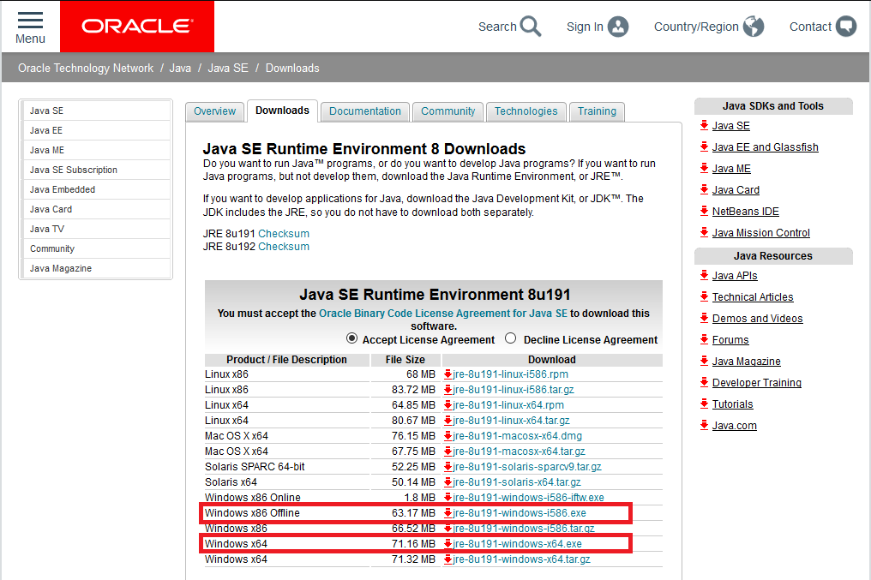

If you are going to install JRE Java for the first time in your computer first you should know if your computer is a 32 bits device or a 64 bits device. As a general rule, those computers with more than 4GB of memory generally are a 64 bits device. On the other hand those computers with less than 4GB of memory are a 32 bits device.

If your computer is a 32 bits device download Java from the link which is inside the first red rectangle in the chart.

Or use this direct url:<https://download.oracle.com/otn-pub/java/jdk/8u191-b12/2787e4a523244c269598db4e85c51e0c/jre-8u191-windows-i586.exe>

If your computer is a 64 bits device download Java from the second link which is inside the red rectangle in the chart

Or use this direct url:<https://download.oracle.com/otn-pub/java/jdk/8u191-b12/2787e4a523244c269598db4e85c51e0c/jre-8u191-windows-x64.exe>

Then follow the Java instructions given during the installation.

Once you have installed Java JRE in your computer you should download the .rar file founded in this URL:<https://github.com/pfernandezgr/gamete-simulator/>

Then extract the files in the computer directory you choose

After extract the files you will see a folder called lib, a file with the name Input Data Base other file named Output Data Base and the file called GametesSimulator.jar

Do double click over the file GametesSimulator.jar and after that the following window of dialogue is going to appear:

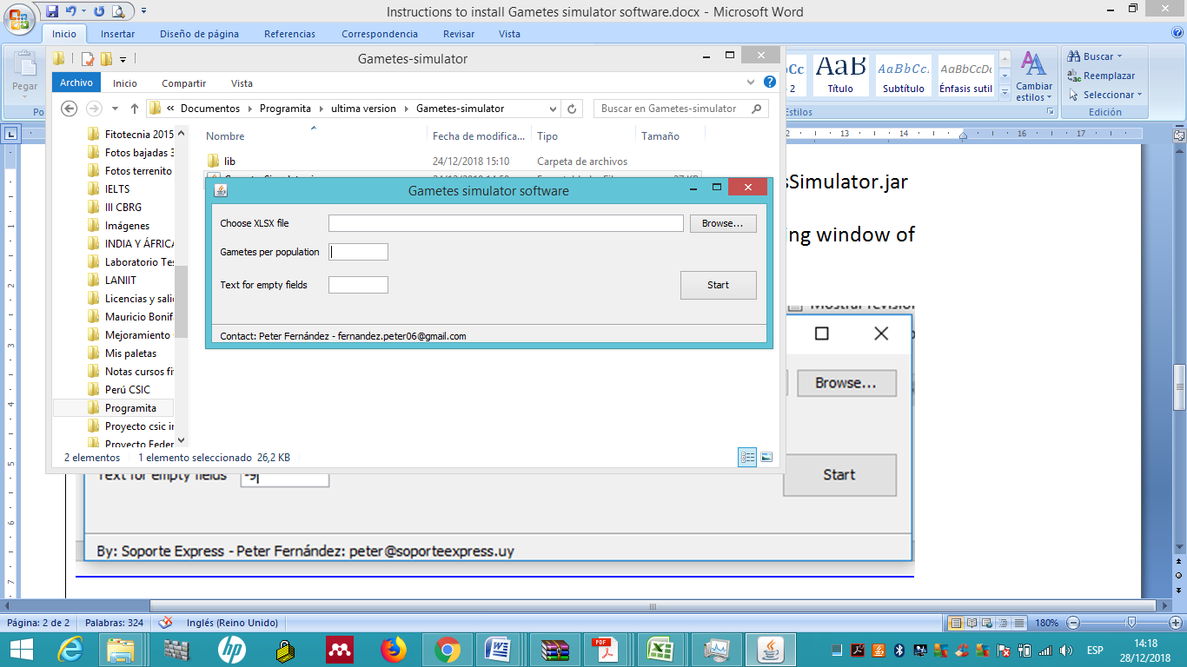

Figure 2 Main window for the programme. First choose the XLSX file which must be according to the Figure 1 format or choose the file Prove Data Base in order to try the software. Then complete with the number of gametes to be simulated within each population and after that write the character or text that will fill empty spaces as required for the output ( If you are going to use the output of this programme as input in Structure you should put -9). Finally press Start

After press Start Gamete Simulator Software begin to run. If the input database is too big, so many markers and populations, the number of gametes to be simulated should be affordable by the memory of your computer in order to work properly and two different outputs are generated in different moments (esto creo va a ser mejor que salga sólo el output final y no el intermedio y así abrá un sólo output). Both outputs are an excel file that should be named and stored in the computer directory the user choose. The file which is generated at the second time is the one which should be used to prepare the .txt file that it will be then used as input in the Structure programme ( Pritchard et al. 2000). (See instructions to prepare the .txt file as an input for Structure in the figure 4 of the article and also you can see in this site the excel data base "Second output with only the information and format required for Structure" then this data base should be stored as a .txt file).